Question(s): | 13/16 |  | Meeting, date: |  | Geneva, 19-23 July 2010
SG, GSI, …: | IPTV-GSI | WP: | 2 | Intended type of document (R-C-TD): |  | TD
Source: | Acting Editor H.IPTV-CONF.7
Title: | Updated new Draft Recommendation H.IPTV-CONF.7 “H.770 conformance testing specification”
Contact: | Masahito KAWAMORI  NTT  Japan |  |  |  | Tel: +81 468 59 2517  Fax: +81 46 855 3495  Email: kawamori.masahito@lab.ntt.co.jp
Contact:
Please don’t change the structure of this table, just insert the necessary information.

Summary
This document is the output text of updated draft Recommendation H.IPTV-CONF.7 “H.770 conformance testing specification” agreed by the Q13/16 meeting of IPTV-GSI (Geneva, 17 – 21 May 2010).

New Draft Recommendation H.IPTV-CONF.7
H.770 conformance testing specification
Summary
The purpose of conformance testing is to increase the probability that different implementations are able to interconnect. Conformance testing in this Recommendation explains test specifications regarding service discovery specified in ITU-T Rec.H.770 “Mechanisms for service discovery and selection for IPTV services”. The test involves testing both the capabilities and behaviour of an implementation, and checking what is observed against the conformance requirements in the Recommendation and against what the implementer states the implementation capabilities are.
<Mandatory material>
Keywords
Conformance, IPTV, service discovery, service provider discovery, detailed service offer discovery, metadata, semantics of metadata, transport protocols, encoding, IPTV terminal device
<Optional>
Introduction
<Optional - This clause should appear only if it contains information different from Scope and Summary>
CONTENTS
1 Scope 4
2 References 4
3 Definitions 5
3.1 Terms defined elsewhere: 5
3.2 Terms defined in this Recommendation 7
4 Abbreviations and acronyms 8
5 Introduction 8
5.1 Scope 8
5.2 Conformity requirements 9
5.3 Test scenarios 10
5.4 Test methods 11
5.4.1 Test system 11
5.4.2 Conformance log 13
5.5 Proformas of implementation conformance statement (ICS) 13
6 Conformance for service provider discovery 13
6.1 Metadata conformance 13
6.2 Encoding conformance 13
6.3 Transport conformance 13
6.4 Procedure to test service provider discovery 13
7 Conformance for detailed service offer discovery 14
7.1 Metadata conformance 14
7.2 Encoding conformance 14
7.3 Transport conformance 14
7.4 Procedure to test detailed service offer discovery 14
Annex A <Annex Title> 15
Appendix I Check-lists for conformance test 15
I.1 Service provider discovery information 15
I.2 Detailed service offer information 16
I.3 What is to be tested 18
I.4 How to use check-lists 18
Appendix II Reference points for conformance test 19
II.1 Reference point E0 19
II.2 Reference Point E5 19
II.3 Reference point E6 19

Draft new ITU-T Rec. H.IPTV-CONF.7
H.770 conformance testing specification

- Scope
This Recommendation specifies a set of tests and procedures designed to indicate whether IPT V terminal devices meet the normative requirements concerning semantics of metadata elements/attributes and its transportation methods specified in ITU-T Rec. H.770. This set of conformance tests can provide a basic level of interoperability testing.
TBD

References
The following ITU-T Recommendations and other references contain provisions, which, through reference in this text, constitute provisions of this Recommendation. At the time of publication, the editions indicated were valid. All Recommendations and other references are subject to revision; users of this Recommendation are therefore encouraged to investigate the possibility of applying the most recent edition of the Recommendations and other references listed below. A list of the currently valid ITU-T Recommendations is regularly published.
The reference to a document within this Recommendation does not give it, as a stand-alone document, the status of a Recommendation.

[ITU-T H.770] Recommendation ITU-T H.770 (2009), Mechanisms for service discovery and selection for IPTV services
[ITU-T X.290] Recommendation ITU-T X.290 (1995), OSI conformance testing methodology and framework for protocol Recommendations for ITU-T applications – General concepts
ISO/IEC 9646-2:1994, Information technology – Open Systems Interconnection – Conformance testing methodology and framework – Part 2: Abstract test suite specification
[ITU-T X.291] Recommendation ITU-T X.291 (1995), OSI conformance testing methodology and framework for protocol Recommendations for ITU-T applications – Abstract test suite specification
ISO/IEC 9646-2:1994, Information technology – Open Systems Interconnection – Conformance testing methodology and framework – Part 2: Abstract test suite specification.
[ITU-T X.293] Recommendation ITU-T X.293 (1995), OSI conformance testing methodology and framework for protocol Recommendations for ITU-T applications – Test realization
ISO/IEC 9646-4:1994, Information technology – Open Systems Interconnection – Conformance testing methodology and framework – Part 4: Test realization.
[ITU-T X.296] Recommendation ITU-T X.296 (1995), OSI conformance testing methodology and framework for protocol Recommendations for ITU-T applications – Implementation conformance statement
ISO/IEC 9646-7:1995, Information technology – Open Systems Interconnection – Conformance testing methodology and framework – Part 7: Implementation Conformance Statement.
ISO/IEC TR 10000-1:1992, Information Technology – Framework and taxonomy of International Standardized Profiles – Part 1: Framework.

- Definitions

  - Terms defined elsewhere:

- Application [ITU-T Y.101]: A functional implementation realized as software running in one or spread over several interplaying hardware entities.
- Broadcast [ITU-T M.60]: One-way transmission of TV signals from one point to two or more other points
- Conformance log [ITU-T X.290] : A human-readable record of information produced as a result of a test campaign, which is sufficient to record the observed test outcomes and verify the assignment of test results (including test verdicts).
- Conformance Testing [ITU-T X.290] : Testing the extent to which an IUT is a conforming implementation.
- Conforming Implementation [ITU-T X.290] : An IUT which satisfies both static and dynamic conformance requirements,consistent with the capabilities stated in the ICS(s).
- Content [ITU-T T.174]: Encoded generic value, media or non-media data
- Dynamic conformance requirement [ITU-T X.290] : One of the requirements which specifies what observable behaviour is permitted by the relevant specification(s) in instances of communication.
- Electronic Content Guide (ECG) [ITU-T H.721]: A service navigation application used especially for streamed and downloaded content. ECG deals with metadata unlike SI used in terrestrial broadcasting.
- Electronic Program Guide (EPG) [ITU-T J.90]: A service navigation interface which is used especially for programs.
NOTE - in some traditional Broadcast Services, EPG is defined as an on-screen guide used to display information on scheduled live broadcast television programs, allowing a viewer to navigate, select, and discover programs by time, title, channel, genre. This traditional definition does not cover “catalogues” for on-demand and download services (sometimes called Electronic Content Guide (ECG), Broadband Content Guide (BCG)) and bi-directional interactive service (sometimes called Interactive Program Guide (IPG)) for end-user interaction with a server or head-end.
- End-user [ITU-T Y.1910]: The actual user of the products or services.
NOTE - The end-user consumes the product or service. An end-user can optionally be a subscriber.
- EPG provider [ITU-T J.90]: The entity that collects collates and assembles the elements of information that constitute the EPG database.
- Implementation conformance statement (ICS) [ITU-T X.290] : A statement made by the supplier of an implementation or system claimed to conform to a given specification, stating which capabilities have been implemented
- Implementation conformance statement (ICS) profoma [ITU-T X.290] : A document, in the form of a questionnaire, which when completed for an implementation or system becomes an ICS.
- Implementation under test (IUT) [ITU-T X.290] : An implementation of one or more OSI protocols in an adjacent user/provider relationship, being that part of a real open system which is to be studied by testing.

- IPTV [ITU-T Y.1901]: Multimedia services such as television, video, audio, text, graphics, data delivered over IP-based networks managed to support the required level of QoS/QoE, security, interactivity and reliability.
- IPTV terminal device [ITU-T Y.1901]: A terminal device which has ITF functionality, e.g. a STB.
- IPTV Terminal Function (ITF) [ITU-T Y.1901]: The functionality within the home network that is responsible for terminating the IP signal, and converting the content into a renderable [i.e. enabling to be seen and/or heard] format.
- Linear TV [ITU-T Y.1901]: A television service in which a continuous stream flows in real time from the service provider to the terminal device and where the user cannot control the temporal order in which contents are viewed.
- Metadata [ITU-T Y.1901]: Structured, encoded data that describe characteristics of information-bearing entities to aid in the identification, discovery, assessment, and management of the described entities.
NOTE - EPG metadata has many applications and may vary in depth from merely identifying the content package title or information to populate an EPG to providing a complete index of different scenes in a movie or providing business rules detailing how the content package may be displayed, copied, or sold.
- Multimedia [ITU-T J.148]: The combination of multiple forms of media such as audio, video, text, graphics, fax, and telephony in the communication of information.
- Middleware [ITU-T Y.1901]: A layer of software between applications and resources, which consists of a set of service enablers that allow multiple functionalities running on one or more devices in an IPTV system to interact across a network

- Package [ITU-T Y.1901]: A collection of content components that in some combination (either all or a subset) together provide an end-user experience and are intended to be used together.
NOTE - A package can be instantiated with or without audio visual content depending on scenarios, in which audio visual content and package can be tightly associated or can be loosely coupled enough to be handled (generation, delivery, consumption) independently.
- Pass (verdict) [ITU-T X.290]: A test verdict given when the observed test outcome gives evidence of conformance to the conformance requirement(s) on which the test purpose of the test case is focused, and when no invalid test event has been detected.
- Portal [ITU-T H.721]: A portal presents information from diverse sources in a unified manner and provides a way to attach the communication services.
- Question [ITU-T X.290]: The question to be answered in the intersection of an ICS item and either a support column (i.e. “Is this item supported in the context applying to this table and column?”) or supported values column (i.e. “What values are supported for this item in the context applying to this table and column?”) in an ICS proforma table.

- Semantics [ITU-T Z.341]: The rules and conventions governing the interpretation and assignment of meaning to constructions in a language
- Service [ITU-T Y.101]: A structure set of capabilities intended to support applications.
- Service Information (SI) [ETSI EN 300 468]: Digital data describing the delivery system, content and scheduling/timing of broadcast data streams, etc.
NOTE - It includes MPEG-2 PSI together with independently defined extensions.

- Service provider [ITU-T M.1400]: A general reference to an operator that provides telecommunication services to customers and other users either on a tariff or contract basis. A service provider may or may not operate a network. A service provider may or may not be a customer of another service provider.
- Set-top box (STB) [ITU-T J.183]: A device that contains demodulator, de-multiplexer, decoder, other functionalities and interfaces related to signal reception and presentation of the distributed programme at the subscriber's site.
- Static conformance requirement [ITU-T X.290]: One of the requirements that specify the limitations on the combinations of implemented capabilities permitted in a real open system which is claimed to conform to the relevant specification(s).
- Stream [ITU-T J.200]: A unidirectional continuous flow of content.
- Subscriber [ITU-T M.3050.1]: The subscriber is responsible for concluding contracts for the services subscribed to and for paying for these services.
- Syntax [ITU-T M.3030]: The structure of expressions in a language, and the rules governing the structure of a language. The relationships among characters or groups of characters, independent of their meanings or the manner of their interpretation and use. (ISO/IEC 11179-1).
- Telecommunication service [ITU-T F.700]: Set of telecommunication capabilities that work in a complementary and cooperative way in order to let users perform applications.
- Terminal device (TD) [ITU-T Y.1901]: An end-user device which typically presents and/or processes the content, such as a personal computer, a computer peripheral, a mobile device, a TV set, a monitor, a VoIP Terminal or an audio-visual media player.
- User device [ATIS-0800002]: Also known as Home Network End-Device (HNED), Home Network Device (HND), Consumer Equipment (CE), terminal and physical device. A piece of hardware equipment running its software and attached to a Home Network and being identified by a GUID, e.g. a MAC address. A single Device can be used by one or more
- Verdict [ITU-T X.290]: A statement of “pass”, “fail” or “inconclusive”, as specified in an abstract test case, concerning conformance of an IUT with respect to that test case when it is executed.
- Video on demand (VoD) [ITU-T Y.1901]: A service in which the end-user can , on demand, select and view a video content and where the end-user can control the temporal order in which the video content is viewed (e.g. the ability to start the viewing, pause, fast forward, rewind, etc).
NOTE - The viewing may occur some time after the selection of the video content.

Terms defined in this Recommendation
This Recommendation defines the following terms:

3.2.1 <Term 3>: <definition>

Abbreviations and acronyms
This Recommendation uses the following abbreviations and acronyms:
ATS | Abstract test suite
AV | Audio video
BCG | Broadband content guide
CAS | Conditional access system
DRM | Digital rights management
DVBSTP | DVB SD&S transport protocol
ECG | Electronic content guide
EPG | Electronic program guide
HTTP | Hyper text transport protocol
IPG | Interactive program guide
ICS | Implementation conformance statement
IUT | Implementation under test
SADS | Service and application discovery and selection
SCP | Service and content protection
SI | Service information
SP | Service provider
URI | Uniform resource indicator
URL | Uniform resource locator
VOD | Video on demand
XML | Extensible mark-up language

- Introduction

Scope
A real system is said to exhibit conformance if it complies with the requirements of applicable specifications specified byITU-T Recommendation in its communication with other real systems. ITU-T Recommendation [ITU-T H.770] includes specifications of service discovery processes that specify metadata, metadata transport protocols or protocol profiles, and metadata encoding rules or information objects. As to detailed service discovery processes, the introduction part of [ITU-T H.770] illustrate following processes towards content acquisition:
- SP Discovery: Discovery of the Service Providers available on the network;
- SP Service discovery: Discovery of the services offered by a specific or all Service Providers;
- SP Content discovery: Discovery of the individual services or contents from a specific Service Provider;
- Content selection & acquisition: At the end of the navigation through the offered services and contents, the end-user selects a service or content and acquires it.
Scope of this Recommendation regarding conformity test of [ITU-T H.770] is the same as [ITU-T H.770] (i.e., SP discovery and SP service discovery). Next Figure also shows the scope of this Recommendation.

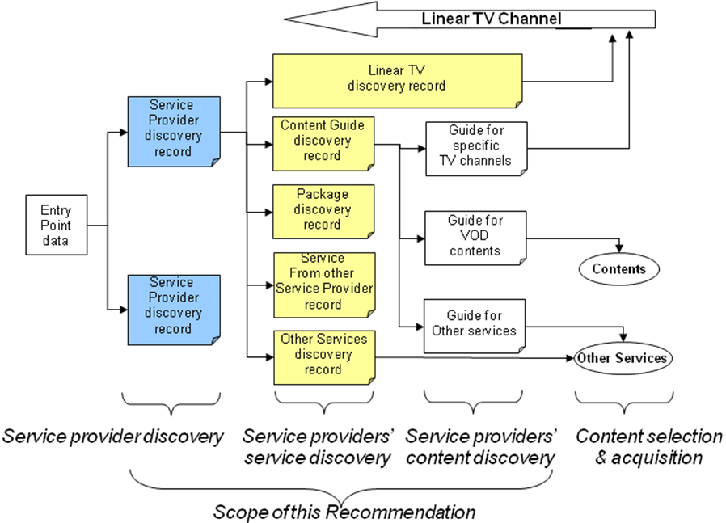
Figure 5-1: From entry point data to service/content acquisition
Note: Details of scope of this document is highlighted with blue and yellow.
This Recommendation use a term “base specifications” as a meaning of specifications defined in [ITU-T H.770] for conformance testing.

Conformity requirements
To claim compliance with base specifications, an IPTV terminal device has to accept and make use of:
- all mandatory elements/attributes specified in base specifications;
- all conditional elements/attributes for which at least one of them is mandatory;
- all the conditional elements/attributes which are mandatory if an optional element/attribute is present;
- all optional elements should be accepted even if not used
Requirements of testing in this Recommendations are categorized into followings [ITU-T X.290]:
- static conformance requirements: specifying the limitation on the combinations of implemented capabilities (e.g., metadata, transport protocols) described in sub-clause 6.1, 6.2, 6.3, 7.1, 7.2, 7.3 and Appendix I. These are claimed to be supported by using implementation conformance statement (ICS).
- dynamic conformance requirements: specifies what observable behavior described in sub-clause 6.4 and 7.4

Test scenarios
Linear TV and VOD are treated as basic IPTV services in [ITU-T H.770] according to [b_ITU-T Y.Sup5]; therefore, these two services are appropriate as test cases. Diagrams in [ITU-T H.770] have already illustrated typical steps to select services by using base specifications. Figure 5.3-1 shows processes to reach specific Linear TV service channel, and Figure 5.3-2 shows processes to select specific VOD services.
Figure 5.3-1 Example of live channel selection through a service guide
as per Figure 12-1 of [H.770]

Figure 5.3-2 Example of content selection through a VoD Guide
as per Figure 12-2 of [H.770]
Test objects regarding metadata in this Recommendation are as follows:
- Linear TV discovery record: specifying to provide a way to directly select Linear TV chnannels
- Content Guide discovery record: being able to provide a convinient way to handle service selection in both Linear TV and VOD
Hence, following test cases for conformatnce testing regarding basic IPTV services are possible:
- Scenario 1: Linear TV discovery using a linear TV discovery record;
- Scenario 2: Linear TV discovery using a content guide discovery record;
- Scenario 3: VOD services discovery using a content Guide Discovery record
Note 1: Current content guide discovery specifications can also present multiple content guides locations within a record (ex. content guide discovery information consists of a provider 1’s Linear TV guide and a provider 2’s VOD guide).
Note 2: In the case of a Linear TV service, scenario 1 and scenario 2 may be combined into one scenario (e.g., access information of SI stream is provided with a linear TV record and locations of contents themselves are provided with a content guide record).

  - Test methods

Test system
A test environment consists of a test system, which provides communication capabilities in order to transport metadata in service discovery processes, and an IPTV terminal device as implementation under test (IUT).

A conformance test environment is specified in two parts: (a)mandatory specifications under which the embedding is to be done according to base specifications, and (b)optional specifications which are convenient to execute the test itself (e.g., an application to check test result(s)).
The test environment in this Recommendation is required to equip with:
- Metadata delivery functionality: a HTTP server for pull mode and/or DVBSTP/Flute server for push mode according to the IPTV terminal device
- Metadata storage functionality: generic file system and/or data base; however, the detailed specification is not defined in this Recommendation
- Network functionality: a unicast network for pull mode and/or multicast network for push mode. IPv4 and/or IPv6 shall be selected based on the specification of the IPTV terminal device.
  - Details of transport protocols are described in clause 6.3 and 7.3 respectively.
- Conformance log generator: watch the communication between the test system and the IPTV terminal device, and generate the log (e.g., packet capturing software).
The test environment is recommended to equip with:
- Content guide functionality: it is useful to check on display of the IPTV terminal device whether service discovery process is passed or not; however, this functionality is depended on the implementation of the IPTV terminal device.
The test environment can optionally equip with:
- Content delivery functionality: presentation of content is out of scope

Figure 5.3-1: Test environment for local testing
Preceding the conformance testing, the specifications of the test environment shall be shown (e.g., software product xyz ver. 1.2.1 as HTTP server) [ITU-T X.291].

Conformance log
A conformance log is a human-readable record of information produced as a result of a test campaign, sufficient to record the observed test outcomes and verify the assignments of test verdicts. This information combines the observations of the actual test events which occur when the test system is run against an IPTV terminal device, with information which relates those events to the test cases concerned [ITU-T X.293].
In each steps when an IPTV terminal device communicate with the test system described in sub-clause 6.4 and 7.4, conformance log should be collected and checked in a verdict process regarding both static and dynamic conformance requirements described in sub-clause 5.2.

Proformas of implementation conformance statement (ICS)
The specific requirements to be met by suppliers in respect of each ICS they are to provide, shall be stated in base specifications. The ICS proforma shown in Appendix I “Check-lists” is in the form of a questionnaire to be completed by the supplier or implementer [ITU-T X.291].
Note: [ITU-T H.770] specifies just semantics of elements/attributes, and detailed syntaxes of the elements/attributes (e.g., name of elements, schema of record) have been studied in another document; therefore, relations between base specifications and implementation ones should be clearly indicated by filling-in columns “Remark”.

Conformance for service provider discovery

Metadata conformance
The metadata for service provider discovery are specified in sub-clause 7.1 of [ITU-T H.770]. Tables of corresponding elements/attributes of check-list in Appendix I.1 shall be filled-in and done verdict.

  - Encoding conformance
The encoding formats for service provider discovery are specified in sub-clause 7.3 of [ITU-T H.770]. An encoding part of the check-list in Appendix I shall be filled-in and done verdict.

  - Transport conformance
The transport protocols for service provider discovery are specified in clause 8 of [ITU-T H.770]. A protocol relevant part of the check-list in Appendix I shall be filled-in and done verdict.

Procedure to test service provider discovery
A functionality regarding service provider discovery that claims conformance with base specifications shall pass the following normative test as observation of behaviors of an IPTV terminal devices:
- A test metadata shall be created with manners specified by sub-clause 6.1 and 6.2.
Note: To avoid an unnecessary problem, validation of the metadata should be checked beforehand.

- Store the metadata for the given test in the repository of a server in a test system accessed by the IPTV terminal device
- A test IPTV terminal acquires the metadata stored in previous step over an IP network with at least one of the following methods specified by sub-clause 6.3
- metadata delivery over unicast (pull mode)
- metadata delivery over multicast (push mode)
Note: the timing of acquiring metadata depends on implementation of the IPTV terminal device (e.g., power-on, operations through a resident application).
- Test pass if the IPTV terminal (interprets the metadata and) automatically accesses to a server indicated by the metadata
Note: Conformance log should be recorded in third and fourth step.

Conformance for detailed service offer discovery

Metadata conformance
The metadata for detailed service offer discovery are specified in sub-clause 10.1, 10.3 and 10.4 of ITU-T Rec. H.770. Tables of corresponding elements/attributes of check-list in Appendix I.2 shall be filled-in and done verdict.

  - Encoding conformance
The encoding formats for detailed service offer discovery are specified in sub-clause 10.6 of [ITU-T H.770]. An encoding part of the check-list in Appendix I shall be filled-in and done verdict.

  - Transport conformance
The transport protocols for detailed service offer discovery are specified in sub-clause 11 of [ITU-T H.770]. A protocol relevant part of the check-list in Appendix I shall be filled-in and done verdict.

  - Procedure to test detailed service offer discovery
A functionality regarding detailed service offer discovery that claims conformance with [ITU-T H.770] shall pass the following normative test:
- A test metadata shall be created with manners specified by sub-clause 7.1 and 7.2. .
Note: To avoid an unnecessary problem, validation of the metadata should be checked beforehand.

- Store the metadata file for the given test in the repository of server accessed
- Service provider discovery process shall be done because an location of a server in next step is provided through this step
- An IPTV terminal acquires the metadata stored in second step over an IP network with at least one of the following methods specified by sub-clause 7.3
- metadata delivery over unicast (pull mode)
- metadata delivery over multicast (push mode)
- Test pass if the test IPTV terminal interprets the metadata and automatically accesses to a server indicated by the metadata
Note 1: An access log shall be collected in fourth and fifth step.
Note 2: This normative test does not require executing a presentation of an EPG/ECG or a service after third step.

Annex A
<Annex Title>
(This annex forms an integral part of this Recommendation)
<Body of annex A>

Appendix I
Check-lists for conformance test
(This appendix does not form an integral part of this Recommendation)

A column “M/O/C” in following tables shows requirement levels of elements/attributes for reference. Mandatory elements/attributes are shown “M”, optional ones are shown as “O” and conditional requirements are shown as “C”.
A column “Support” can be put down whether [ITU-T H.770] elements/attributes are used or not [ITU-T X.296].
The common notations for support answers are:
- supported Y, y, YES or yes
- not supported N, n, NO, no
- no answer required N/A, n/a or “-”
A column “Remarks” can be put down detailed relevancies to [ITU-T H.770] specifications. If optional elements/attributes are used according to local rules, it should be also described the conditions (ex., only if Linear TV is served, this elements is required) in order to objectively check conformities regarding their semantics.

I.1 Service provider discovery information
Table I.1-1: Service provider information record
Element / Attribute | M/O/C | Support | Remark
Record Type | M
Record Version | M
Individual Service Provider Information | M

Table I.1-2: Individual service provider information elements/attributes
Element / Attribute | M/O/C | Support | Remark
Service Provider Identifier | M
Individual Service Provider Information Version | M
Service Provider Logo URI | O
Service Provider Name | O
Service Provider Description | O
Web Portal URL | O
Service Offer Summary (s) | M

Table I.1-3: Service offer summary elements/attributes
Element / Attribute | M/O/C | Support | Remark
Push Address | C  (Note)
Pull URL | C  (Note)
Offer Type | O
Segment Identifier and Version | O
NOTE - One of them is required to be presented.

I.2 Detailed service offer information
Table I.2-1: Linear TV discovery record
Element / Attribute | M/O/C | Support | Remarks
Record Type | M
Service Provider Identifier | M
Record Version | M
Metadata server URL | O
Portal URL | O
Purchase Information URL | O
Linear TV Service(s) | M

Table I.2-2: Linear TV Services elements/attributes
Element / Attribute | M/O/C | Support | Remark
Service Identifier | M
Original Network Id | O
Transport Stream Id | O
Service Id | O
Max bit rate | O
Service Location(s) | M
Audio Coding | O
Video Coding | O
Service Availability | O
Streaming Type | O
Multiplex Mode | O

Table I.2-3: Service location elements/attributes
Element / Attribute | M/O/C | Support | Remark
IP Multicast Address | M
IP Multicast Port | M
IP Multicast Source | O  (Note)
Unicast URL | O
NOTE - Source address is mandatory when IPv6 multicast is deployed.
Table I.2-4: FEC elements/attributes
Element / Attribute | M/O/C | Support | Remark
FEC Base Layer Multicast Address | M
FEC Enhancement Layer Multicast Address | O
Maximum Packet Number in blocks | O
Maximum FEC Block Duration | O
FEC specific information | C  (Note)
NOTE - This information is required when FEC enhancement layer is used.

Table I.2-5: Service availability elements/attributes
Element / Attribute | M/O/C | Support | Remark
Country Code | O
Availability | O
Region Codes | O

Table I.2-6: Additional linear TV discovery elements/attributes
Element / Attribute | M/O/C | Support | Remark
Type of service | M
Priority SI Source | O
Service Name | O
Service Description | O
Content Guide Discovery record Identifier(s) | O
Preferred Content Guide Discovery record Location(s) | O
Service Genre(s) | O
Announcement stream | O
Secondary Service Id | O
Mosaic Information | O

I.3 What is to be tested
It should be identified that the IPTV services scenarios and/or delivery mode (i.e., protocols) and information objects which are to be the focus of the conformance assessment [ITU-T X.296]. It is necessary to distinguished to put down a process (e.g., service provider discovery) for the case that different modes are used in each process. This can use a following table.
Table I.3-1: Table of what is to be tested
IPTV service | Process | Mode | Protocol (version) | Information objects | Encoding
 | Service provider discovery |  |  | Service provider information
 | Detailed service discovery

I.4 How to use check-lists
Check-lists shown in Appendix of this Recommendation can be used to confirm the status of usage of metadata for service provider discovery and detailed service discovery.
Table I.4-1: Example of description of checking elements/attributes
Element / Attribute | M/O/C | Support | Remark
Record Type | M | y | Equivalent to a test element “SP”
Record Version | M | y
OfferType | O | y | Equivalent to a test element “Linear TV”. Only if Linear TV is provided, this element is required

Table I.5-2: Example of description of another checking
IPTV service | Process | Mode | Protocol (Version) | Information objects | Encoding (Compression)
Linear TV | Service provider discovery | Pull | TCP  HTTP(1.1) | Service provider information | XML  (No-compress)
Linear TV | Detailed service discovery | Pull | TCP  HTTP(1.1) | Linear TV information | XML  (No-compress)

Appendix II
Reference points for conformance test
(This appendix does not form an integral part of this Recommendation)
Next figure shows only reference points concerning IPTV terminal devices extracted from [b_ITU-T Y.1910]. Left side round-square boxes are server-side or network-side functionalities. Following reference points are related to this draft Recommendation.

II.1 Reference point E0
The E0 reference point is between SADS client functional block and the server-side SADS functional block [b_ITU-T Y.1910].
This reference point is used to discover service provider/services themselves, and select IPTV services and applications.

II.2 Reference Point E5
The E5 reference point is between the multicast content delivery client functional block and the multicast control point functional block [b_ITU-T Y.1910].
This reference point is used to exchange messages for joining multicast channels, e.g. IGMP messages.

II.3 Reference point E6
The E6 reference point is between the unicast content delivery client functional block and the content delivery control functional block [b_ITU-T Y.1910].
This reference point is used to exchange content control message, e.g. video recording commands.

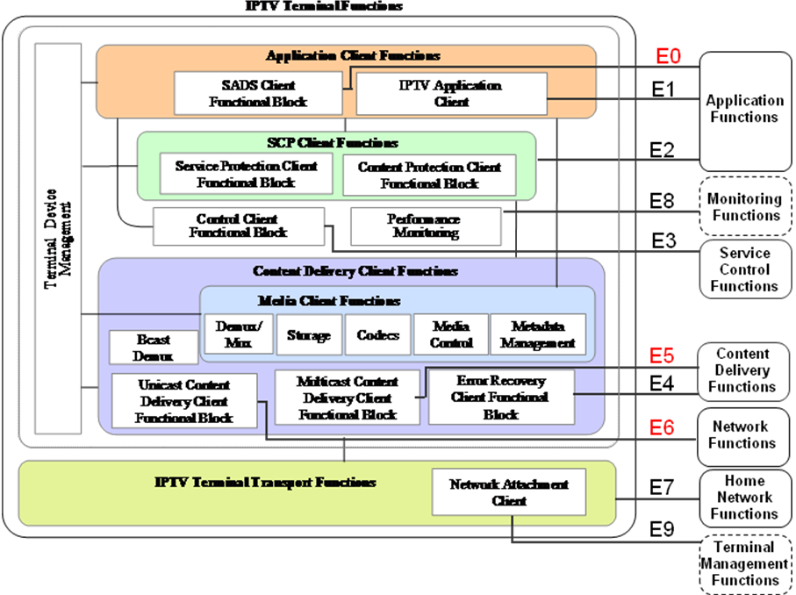
Figure II-1: Reference points on protocols of IPTV terminal devices as per [b_HTSP.IPTV-PITD]

Bibliography
[b_ITU-T Y.Sup5] Recommendation ITU-T Y.Sup5 (2008), ITU-T Y.1900-series – Supplement on IPTV service use cases
[b_ITU-T Y.1910] Recommendation ITU-T Y.1910 (2008), IPTV functional architecture
[b_HTSP.IPTV-PITD] ITU-T draft Technical Paper HTSP.IPTV-PITD [TD-321-GEN/16] (2010), Protocols handled by IPTV terminal devices
[b_ITU-T H.264.1] ITU-T Recommendation H.264.1 (2009), Conformance specification for H.264 advanced video coding
[b_H.IPTV-MDSD] ITU-T draft Recommendation H.IPTV-MDSD [TD-37 WP/2/16] (2010), Metadata schema for service discovery and content consumption for IPTV services

