INTERNATIONAL TELECOMMUNICATION UNION |  | IPTV-GSI
TELECOMMUNICATION  STANDARDIZATION SECTOR  STUDY PERIOD 2005-2008 |  | TD 115 (IPTV-GSI)
English only
Original: English
Question(s): | 13/16; IPTV-GSI | Geneva, 23-27 June 2008
TEMPORARY DOCUMENT
Source: | Editor
Title: | Draft Recommendation H.IPTV-SDC: Mechanisms for service discovery up to consumption for IPTV (IPTV-GSI, Geneva, 23-27 June 2008)

Summary
This is a new draft Recommendation for service discovery and its related areas for IPTV. This document describes service discovery, channel and content identification and location resolution for IPTV.

CONTENTS

1 Scope 2
2 References 2
3 Definitions 2
3.1 This working document uses the following terms defined elsewhere: 2
3.2 This working document defines the following terms: 2
4 Abbreviations and acronyms 2
5 Introduction 2
6 Service Provider Discovery process 2
7 Service Provider information 2
8 Service Provider Information delivery protocol 2
9 Service Discovery process 2
10 "Detailed Service Offer" information 2
10.1 Broadcast discovery record - TS Full SI 2
10.2 Broadcast discovery record - TS Optional SI 2
10.3 Package discovery record 2
10.4 "Content Guide Offer" record 2
10.5 "Service From other Services Providers" record 2
11 "Detailed Service Offer" delivery protocol 2
12 Service selection process 2
13 Service/content delivery protocol 2
13.1 Live Media Broadcast service delivery protocol 2
13.2 Content on Demand service delivery protocol 2
14 Channel Identification and location resolution 2

From service discovery up to consumption for IPTV
- Scope
This document describes service discovery, channel and content identification and location resolution for IPTV.
- References
The following ITU-T Recommendations and other references contain provisions, which, through reference in this text, constitute provisions of this working document. At the time of publication, the editions indicated were valid. All Recommendations and other references are subject to revision; users of this working document are therefore encouraged to investigate the possibility of applying the most recent edition of the Recommendations and other references listed below. A list of the currently valid ITU-T Recommendations is regularly published.
The reference to a document within this working document does not give it, as a stand-alone document, the status of a Recommendation.
[ITU-T F.700] ITU-T Recommendation T.700 (2000), Framework Recommendation for multimedia services
[ITU-T H.222AM1] ITU-T Recommendation H.222.0 Amd 1(2002), Information technology – Generic coding of moving pictures and associated audio information: Systems Amendment 1: Carriage of metadata over ITU-T Rec. H.222.0 | ISO/IEC 13818-1 streams
[ITU-T J.90] ITU-T Recommendation J.90 (2000), Electronic programme guides for delivery by digital cable television and similar methods - Reference operating scenario and requirements
[ITU-T J.94 AM1] ITU-t Recommendation J.94 Amendment 1 (1998), Annex B - Service information delivered out of band for digital cable television systems
[ITU-T J.98] ITU-T Recommendation J.98 (2003), Metadata requirements for video-on-demand in cable networks
[ITU-T J.148] ITU-T Recommendation J.148 (2003), Requirements for an objective perceptual multimedia quality model
[ITU-T J.190] ITU-T Recommendation J.190 (2002), Architecture of MediaHomeNet that supports cable-based services
[ITU-T J.200] ITU-T Recommendation J.200 (2001), Worldwide common core − Application environment for digital interactive television services
[ITU-T Q.1702] ITU-T Recommendation Q.1702 (2002), Long-term vision of network aspects for systems beyond IMT-2000
[ITU-T T.171] ITU-T Recommendation T.171 (1996), Protocols for interactive audiovisual services: Coded representation of multimedia and hypermedia objects
[ITU-T T.174] ITU-T Recommendation T.174 (1996), Application programming interface (API) for MHEG-1
[ITU-T Y.101] ITU-T Recommendation Y.101 (2000), Global Information Infrastructure terminology: Terms and definitions
[ISO/IEC 13818-2] ISO/IEC 13818-2 (2000), Information technology -- Generic coding of moving pictures and associated audio information: Video
[ISO/IEC 14496-12] ISO/IEC 14496-12 (2005), Information technology -- Coding of audio-visual objects -- Part 12: ISO base media file format
[ETSI EN 300 468] ETSI EN 300 468 V1.8.1 (2007), Digital Video Broadcasting (DVB); Specification for Service Information (SI) in DVB systems
[ETSI TS 102 323] ETSI TS 102 323 V1.2.1 (2005), Digital Video Broadcasting (DVB); Carriage and signalling of TV-Anytime information in DVB transport streams
[ATIS-0800002] ATIS standard ATIS-0800002(2006), IPTV Architecture Requirements
- Definitions

This working document uses the following terms defined elsewhere:
- Application [ITU-T Y.101]: A functional implementation realized as software running in one or spread over several interplaying hardware entities.
- Application manager [ITU-T J.200]: The entity that is responsible for managing the lifecycle of the applications. It manages applications running in both the Presentation engine and Execution engine if both are present.
- Application Programming Interface (API) [ITU-T J.200]: Consists of software libraries that provide uniform access to system services. [ITU-T J.200]
Note: In the case of middleware, it is an interface between application layer and middleware service which encapsulates the services offered by the middleware and enable application developer to develop new application.
- Character [ITU-T J.200]: A specific "letter" or other identifiable symbol, e.g. "A".
- Character encoding [ITU-T J.200]: Mapping between an integer input value, and the textual character that is represented by this mapping, e.g. in ASCII value 65 (decimal) is character "A", or shift-JIS for Japanese characters.
- Content [ITU-T T.174]: Encoded generic value, media or non-media data
- EPG provider [ITU-T J.90]: The entity that collects, collates and assembles the elements of information that constitute the EPG database.
- Execution engine (EE) [ITU-T J.200]: instructions and associated data and media content. An execution engine may be implemented with an operating system, computer language compilers, interpreters, and Application Interfaces (APIs), which a procedural application may use to present audiovisual content, interact with a user, or execute other tasks, which are not evident to the user. A common example of an execution engine is the JavaTV software environment, using the Java programming language and byte code interpreter, JavaTV APIs, and a Java Virtual Machine for program execution.
- Home network (HN) [ITU-T J.190]: Short-range communications system designed for the residential environment, in which two or more devices exchange information under some sort of standard control.
- Metadata format [ITU-T H.222AMD1]: Identifies the coding format of metadata.
- Metadata service [ITU-T H.222AMD1]: Coherent set of metadata of the same format delivered to a receiver for a specific purpose.
- Multimedia [ITU-T J.148]: The combination of multiple forms of media such as audio, video, text, graphics, fax, and telephony in the communication of information.
- Multimedia application [ITU-T T.174]: An application which involves the presentation of multimedia information to the user.
- Multimedia service [ITU-T Q.1702]: A service in which the interchanged information consists of more than one type, such as text, graphics, sound, image and video.
- Multimedia representation [ITU-T T.171]: The property of handling several types of representation media.
- Presentation [ITU-T T.411]: The operation of rendering the content of a document in a form perceptible to a human being.
- Presentation engine [ITU-T J.200]: A subsystem in a receiver that evaluates and presents declarative applications consisting of content, such as audio, video, graphics, and text primarily based on presentation rules defined in the presentation engine. A presentation engine also responds to formatting information, or "mark-up", associated with the content, to user inputs, and to script statements, which control presentation behaviour and initiate other processes in response to user input and other events. A common example of a presentation engine is an HTML browser, capable of displaying text and graphic content formatted in HTML, with interactive behaviour programmed in ECMA script.
- Service [ITU-T Y.101]: A structure set of capabilities intended to support applications.
- Stream [ITU-T J.200]: A unidirectional continuous flow of content.
- Telecommunication service [ITU-T F.700]: Set of telecommunication capabilities that work in a complementary and cooperative way in order to let users perform applications.
- User device [ATIS-0800002]: Also known as Home Network End-Device (HNED), Home Network Device (HND), Consumer Equipment (CE), terminal and physical device. A piece of hardware equipment running its software and attached to a Home Network and being identified by a GUID, e.g. a MAC address. A single Device can be used by one or more users.
  - This working document defines the following terms:
- Application instance: An occurrence of an application
- Broadcast TV: One-way transmission of TV signals from one point to two or more other points.
- Character set: See character encoding.
- Content protection: Act of preventing unauthorized use of any content.
- Electronic Content Guide (ECG): A service navigation interface used especially for content streaming and download.
Note: It is sometimes used synonymously with EPG.
- Electronic Program Guide (EPG): A service navigation interface which is used especially for programs.
Note: in some traditional Broadcast Services, EPG is defined as an on-screen guide used to display information on scheduled live broadcast television programs, allowing a viewer to navigate, select, and discover programs by time, title, channel, genre. This traditional definition does not cover “catalogues” for on-demand and download services (sometimes called ECG) and bi-directional interactive service (sometimes called IPG) for end-user interaction with a server or head-end.
Some EPGs utilize web-pages, or teletext to realize this function.
- Electronic Service Guide (ESG): A service navigation interface used especially for available services and contents.
- Extended channel: Means to organise different operation content together, including live channel, TVOD, information service, EPG and so on. For each extended channel, there is a related channel number. [0062]
- Globally Executable MHP (GEM): A terminal specification based on MHP that enables applications to interoperate across OCAP, MHP and other GEM based platforms.
- IPTV Terminal Function (ITF)*: The functionality within the home network that is responsible for terminating the IP signal, and converting the content into a renderable [i.e. enabling to be seen and/or heard] format, e.g. a STB.
*: Based on [ATIS-0800002] with modification
- Interactive Program Guide (IPG): A service navigation interface used especially for bi-directional interactive service with a server or head-end.
Note: It is sometimes used synonymously with EPG.
- Interactive Television (iTV): A service in which the user can send requests, within a browser environment, to the service provider in order to obtain additional information. This capability requires channels to have what is known as a 'return path'.
- Lifetime/Lifecycle of an application: Characterizes the time from which the application is loaded to the time the application is destroyed.
- Metadata: Structured, encoded data that describe characteristics of information-bearing entities to aid in the identification, discovery, assessment, and management of the described entities.
Note: EPG metadata has many applications and may vary in depth from merely identifying the content package title or information to populate an EPG to providing a complete index of different scenes in a movie or providing business rules detailing how the content package may be displayed, copied, or sold.
- Middleware: A layer of software between applications and resources, which consists of a set of service enablers that allow multiple functionalities running on one or more devices in an IPTV system to interact across a network.
- Segmentation: Division of content into different parts, e.g. scenes and chapters.
- Service Navigation: The presentation of information that allows the end-user to discover, select and consume services.
- Service Navigation Interface: A user interface which is intended to provide information on available services, including content that may be accessed by end-users for service navigation.
- Set-top box (STB): A device that contains demodulator, de-multiplexer, decoder, other functionalities and interfaces related to signal reception and presentation of the distributed programme at the subscriber's site.
- Time shifting: A function which allows playback of content after its initial transmission.
- Time-shifted TV: A TV program that has been time shifted.
- User Interface (UI): Also known as UI, a user interface is the sensory and behavioural aspects of a program that are presented to a user. The term is generally used to denote the menuing and navigational constructs of a program.
- Video-on-Demand (VoD): A service in which the subscriber can view video content whenever desired. The operating assumption is that the content is stored on the provider’s VoD server. Subscriber accesses the movie from a library directory which may include search engine that accesses movie description and rating. Subscribers typically have the ability to pause, play, rewind, fast forward the content, or even stop viewing it and return to it at a later time when using this service.
- Abbreviations and acronyms
This document uses the following abbreviations and acronyms.
API Application Programming Interface
AV Audio Video
DVB Digital Video Broadcasting
EPG Electronic Program Guide
ESG Electronic Service Guide
ETSI European Telecommunications Standards Institute
GEM Globally Executable MHP
GIF Graphics Interchange Format
GUI Graphical User Interface
HN Home Network
HTML Hyper Text Mark-up Language
HTTP Hyper Text Transport Protocol
I/O Input / Output
ID IDentifier
IETF Internet Engineering Task Force
IHDN In Home Digital Network
IP Internet Protocol
IPR Intellectual Property Rights
ISDN Integrated Services Digital Network
ISO International Organization for Standardization
ITU International Telecommunication Union
ITV Interactive Television
JDK Java Development Kit
JFIF JPEG File Interchange Format
JPEG Joint Picture Expert Group
LMDS Local Multipoint Distribution System
MAC Media Access Control
MHP Multimedia Home Platform
MIME multipurpose internet mail extensions
MMDS Multipoint Microwave Distribution System
MPEG Moving Picture Experts Group
NTSC National Television Systems Committee
NVOD Near-Video-On-Demand
OCAP OpenCable Application Platform
OS Operating System
OSD On Screen Display
PFR Portable Font Resource
PNG Portable Network Graphics
PSI Program Specific Information
PSIP Program and System Information Protocol
RAM Random Access Memory
ROM Read Only Memory
SI Service Information
TCP Transmission Control Protocol
TS Transport Stream
UDP User Datagram Protocol
UI User Interface
URL Uniform Resource Locator
UTF8 Universal Transformation Format 8
VM Virtual Machine
WAN Wide Area Network
XML eXtensible Markup Language
- Introduction
The service discovery includes a number of steps in the process of content acquisition as illustrated on the following figure.
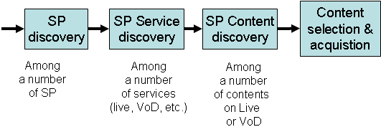
Figure 5-1. From service provider discovery to content acquisition
Here after is the description of the different steps in "Service Discovery" independently of any specific IPTV architecture.
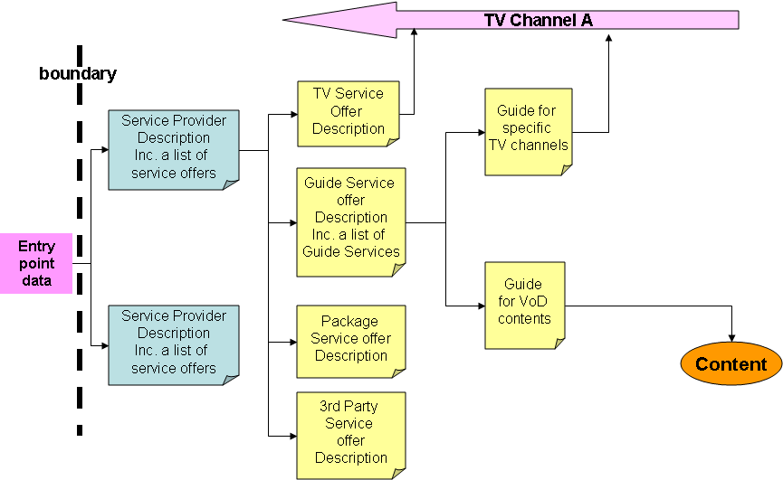
Figure 5-2. From entry point data to service/content acquisition
There are several solutions for the Terminal Device to get "entry point data" but this is part of the network signalling and so considered out of scope.
- Service Provider Discovery process
The first step is to discover the IPTV Service Providers when several Service Providers are available on the network.
In the case where there is only one IPTV Service Provider or if the user is directly registered with one particular Service Provider, this first step may be skipped.

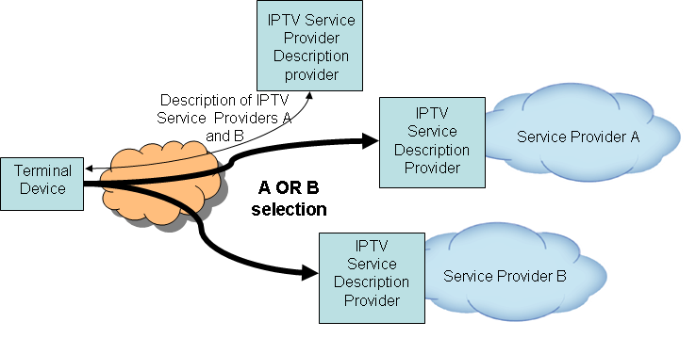
Figure 6-1: Service Provider Discovery with several IPTV service providers
Note: Another figure should be provided to illustrate the case where the Service Provider Discovery information is available from individual Service Providers. In this configuration the discovery of starting entry point(s) provides several entry points, likely to be one for each Service Provider.
In the case where there are several Service Providers and there is no preconfigured Service Provider, it is necessary to provide the end-user device with one or more starting entry point(s) from where to get the description of the Service Providers available on the network and there are different solutions depending on the IPTV Architecture to get these entry points.
Each IPTV Architecture has its own way to make the starting entry point(s) available to the Terminal Device.
A starting entry point might be:
- An IPTV service provider description provider entry point (when there are several IPTV service providers on the network and no specific service provider entry point is provided in the terminal device configuration data)
- An IPTV service provider entry point (when there is only one IPTV service provider on the network or when a specific service provider entry point is provided in the terminal device configuration data). The IPTV service provider maybe running a web-based solution, a metadata-based one or a mixture of them.
Here are two solutions showing how descriptions of available IPTV service providers can be acquired by Terminal Devices, when the entry point is an IPTV Service Provider Description Provider entry point, the first one making of HTTP or S-HTTP protocols and the second making use of the IGMP protocol
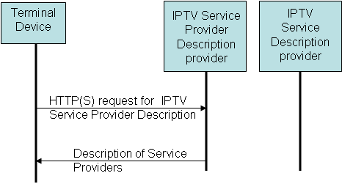
Figure 6-2: HTTP(S) request to get the description of the available IPTV service providers
Note: Is S-HTTP really to be kept as a solution or just HTTP?
In this case the service provider description provider may answer with a set of metadata containing the description of the available service providers.

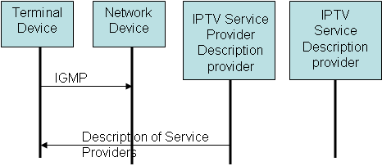
Figure 6-3: IGMP join request to receive the description of the available IPTV service providers
In this case the Service Provider Description Provider sends periodically the set of metadata containing the description of the available Service Providers.

Service Provider Discovery information
This section specifies the first level of information about the Service Providers.
The "Service Provider Discovery Information" record contains the following elements:

Element |  |  | Description | occurrence
Version |  |  | Version to be used for identification of this information | 1
Service provider information |  |  | Set of information for each service provider | 1..*
 | Version |  | Version to be used for identification of this information | 1
 | Pull location |  | URL of service description provider. This element is used for pull type.  Ex.)http://foo.bar.com/description | 0..*
 | Push location |  | Multicast address of service description provider. This element is used for push type. | 0..*
 |  | Source address | Source address specified when the source of multicast stream should be limited. | 0..1
 |  | Multicast address | Multicast address to join | 1
 |  | Destination port number | Destination port number for multicast stream | 1
Each element above is not mandatory. Service Provider Description Providers may choose what they are interested in from those elements. “Occurrence” is just a hint for them when Service Provider Description Providers choose the elements.

- Service Provider Discovery Information delivery protocol

Service Discovery process
In the Service Provider Discovery information, the Terminal Device discovers all Service Providers available on the network.
If a specific Service Provider is already configured in the Terminal Device, the Terminal Device can proceed with a request to the Service Provider for the description of all Services offered by this Service Provider.
If no specific Service Provider is already configured in the Terminal Device and if several Service providers are available, the Terminal Device will display information about the available Service Providers extracted from the Service Provider Discovery Information to allow the user to select one of them.
When the Terminal Device knows the Service Provider the End-User wants to be connected, it can proceed with a request to the Service Provider for the description of all Services offered by this Service Provider.
The entry point for this request can be found in the Service Provider Discovery Information
Here are two solutions showing how descriptions of IPTV services offered by an IPTV Service Provider can be acquired by IPTV Terminal Devices, when the entry point is an IPTV Service Provider entry point, the first one making of HTTP or S-HTTP protocols and the second making use of the IGMP protocol
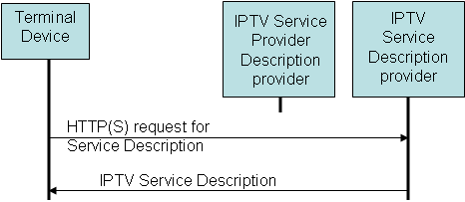
Figure 6-4: HTTP or S-HTTP request for description of the IPTV services offered by a service provider

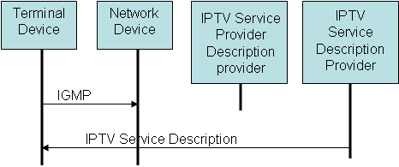
Figure 6-5: IGMP join request to receive the description of the IPTV services offered by a service provider

"Detailed Service Offer" information
This section specifies the detailed description of the Services offered by a Service Provider.
A number of service types which could be offered by Service Providers have been identified and for each of them, metadata has been defined.
The following elements are supposed to be included in “Detailed Service Offer” information returned by Service Provider.

Element |  | Description | occurrence
Version |  | Version to be used for identification of this information | 1
Service offerings |  |  | 0..n
 | Service type | Type of service offering. E.g. IP broadcast, Guide service, Package service, etc. | 1
 | Information | Information of service offering provided. | 1
Each element above is not mandatory. Service Provider Description Providers may choose what they are interested in from those elements. “Occurrence” is just a hint for them when Service Provider Description Providers choose the elements.
The element “Information” included in “Service offerings” would have various elements which depend on a service type. The following subsections describe the detail of this “Information” element.

Broadcast discovery record - TS Full SI
The "TS Full SI" Broadcast Discovery Information Record (BroadcastOffering XML type) provides all the necessary information to find available live media broadcast services which have embedded SI.
Information on individual services is afterwards acquired from the Transport Stream itself through classical use of Service Information.Elements or attributes:
List of live Services
- Identifier(s) of the Metadata Record(s) that carries the information on this offering.
- Pointer to preferred Service/Content Guide
- DNS domain name registered by the Service Provider that uniquely identifies the Service Provider. If this is not present, then the DNS domain name from the DVB IP Offering record is used.
And for each service:
  - A unique host name for the service within the service provider"s domain
  - Network Id of the originating delivery system
  - Transport Stream Id
  - Service Identification within the TS. The service Id is the same as the program number in the corresponding program map table.
  - Maximum bitrate (in kbits/s) of the overall stream carrying the service
  - A number of Service locations (At least one of IP MulticastAddress or RTSP URL shall be present)
    - IP MulticastAddress containing
      - IP multicast address at which the service may be accessed.
      - IP Multicast port at which the service may be accessed.
      - Optionally the IP multicast address of the source of the TS may be provided.
      - RTP or direct UDP streaming. By default, RTP streaming is assumed.
      - IP multicast address and port of the AL-FEC Base Layer stream. This element shall be present if the FECEnhancementLayer element is present.
        - IP Multicast Address for FEC Base Layer (SMPTE-2022-1 [76]). If the IP multicast address is omitted, then the FEC flow is assumed to be on the same multicast address as the original data.
        - IP Multicast Source Address for FEC Base Layer (SMPTE 2022-1 [76]). If the IP multicast source address is omitted, then the FEC flow is assumed to be on the same multicast address as the original data.
        - UDP port for FEC Base Layer.
      - IP multicast address and port of the AL-FEC enhancement stream(s). This element shall only be present if the FECBaseLayer element is present. This element may be repeated for multiple layers.
        - IP Multicast Address for FEC Enhancement Layer (Raptor). If the IP multicast address is omitted, then the FEC flow is assumed to be on the same multicast address as the original data.
        - IP Multicast Source Address for FEC Enhancement Layer (Raptor). If the IP multicast source address is omitted, then the FEC flow is assumed to be on the same multicast address as the original data.
        - UDP port for FEC Enhancement Layer.
      - Maximum number of stream source packets that will occur between the first packet of a source block (which is included) and the last packet for that source block (source or repair).
      - Maximum transmission duration of any FEC Block (source and repair packets).
      - FEC Object Transmission Information for the Raptor code. If an FECEnhancementLayer element is included then this element SHALL be included.
    - RTSP URL to access the service. At least one of IPMulticastAddress or RTSP URL shall be present.
  - Details of the audio coding algorithms and purpose that the service may use.
  - Details of the video coding that may be used by the service.
  - Service availability (support for regionalization). It allows each service to have a list of 'cells' (regions) with which the service is associated. By default, all the single services are available everywhere.. There shall be at most one ServiceAvailability element for each CountryCode.
    - Country for which the availability is being defined.
      - Flag to indicate whether the service is available in the country specified by CountryCode. The default is TRUE. When TRUE, the service is available in the specified country with the exception of those regions identified by Cells. When FALSE, the service is not available in the specified country with the exception of those regions identified by Cells.
    - List of string identifiers representing geographical regions in the country identified by CountryCode. The Cells listed represent the exception to the value supplied by the flag, i.e. the negation of the Availability flag applies to any listed cells.

Broadcast discovery record - TS Optional SI
The "TS - Optional SI" Broadcast Discovery Information Record provides all the necessary information to create a list of available services with sufficient information for the user to make a choice and gives the necessary information on how to access the service.
Here are the elements or attributes to be added to the already identified ones in the "Broadcast discovery record - TS Full SI" for each service:
  - Type of service; it shall be coded as per the relevant SI standard 1. Examples are digital television service, digital radio sound service, mosaic service, data broadcast service, etc.
  - Source of service information to give priority (XML record or SI) in case SI tables are present.
  - Service Name for display in one or more languages; one Service name is allowed per language code, and at least one language shall be provided.
  - Service Description for potential display in one or more languages.
  - Identifier(s) of the Guide Record(s) that carries the information on this service. If this element is present, it shall be used in preference to the Service Description Location.
  - Preferred Guide Record location if any.
  - One or more genre of the service (not individual programmes). For example movie/drama channel or news/current affairs channel.
  - Type of spoken announcements that are supported by the service (for example emergency flash, road traffic flash, etc.). Furthermore, it informs about the transport method of the announcement and gives the necessary linkage information so that the announcement stream can be monitored.
  - Service replacement service Id which may be selected automatically by the HNED when the service being decoded fails.
  - Mosaic description element. It identifies the elementary cells of a mosaic service, groups different elementary cells to form logical cells, and establishes a link between the content of all or part of the logical cell and the corresponding service or package information.

Package discovery record
The Package Discovery Record provides a means for a collection of services to be marketed as, or grouped into, a single entity.
Here are the elements or attributes for this "Package discovery" record:
- Package ID. This ID is allocated by the Service Provider
- A Boolean which indicates in combination with the PackageAvailability element, whether this package shall be presented to the user. The default value is true.
- Package name for display in one or more languages.
- Identifier(s) of the Guide Record(s) that carries the information on this package.
- Preferred Guide location.
- Id(s) of package(s) that are included in the current package.
- List of services forming the package, comprising:
  - Unique host name for the service within the service provider's domain.
  - Service identification (e.g. DVB triplet) by which the service may be known.
  - The URI of additional service description provided in the context of a package; this is not required to acquire a service. A Boolean flag indicates the preferred location for this information.
  - The logical channel number of the service.
  - Package availability (support for regionalization). It allows each package to have a list of 'cells' (regions) with which the package is associated. By default, the package is available everywhere. There shall be at most one PackageAvailability element for each CountryCode.
    - Country for which the availability is being defined.
      - Flag to indicate whether the package is available in the country specified by CountryCode. The default is TRUE. When TRUE, the package is available in the specified country with the exception of those regions identified by Cells. When FALSE, the package is not available in the specified country with the exception of those regions identified by Cells.
    - List of string identifiers representing geographical regions in the country identified by CountryCode. The Cells listed represent the exception to the value supplied by the flag, i.e. the negation of the Availability flag applies to any listed cells.
A service may belong to more than one package. A service does not have to be part of any package.

"Content Guide Offer" record
The "Content Guide Offer" Record provides a means to discover the locations of guides listing the content that is available, either live (e.g. through a Broadcast Offering) or via content on demand.
- Record type: to identify the type of record, here "Content Guide Offer" Information" type.
- Record version. It is incremented with any change to the "Content Guide Offer" record.
The record containing the "Content Guide Offer" Information may contain several offers, each of them containing the following elements:
- Content Guide Offer identifier. It is allocated by the Service Provider.
- Content Guide Offer version. It is incremented with any change to this particular instance of "Content Guide Offer".
- Content Guide Offer name. Several names are possible, each of them associated with a specific language.
- Content Guide Offer description. Several descriptions are possible, each of them associated with a specific language.
- Location where the broadband content guide may be found. Several possibilities can be described (e.g. push mode, HTTP pull mode, SOAP pull mode, etc.)
- Content Guide Offer logo URI. It is a pointer to a Content Guide Offer logo for potential display.
- Content Guide Offer type. It indicates if the content guide relates to live programs, content on demand, both, or some other form of content.
- Target provider of the Content Guide Offer. This is the domain name of the service provider whose content is described by this Content Guide (for example Canal+).
- Content Guide Offer provider name. Several names are possible, each of them associated with a specific language.

"Service From other Services Providers" record
A Service Provider can reference individual services or a complete offering provided by another service provider. Supplying its textual service identifier references a service. Supplying the service provider's DNS domain name without a service list references an entire service provider's offering.
Elements and attributes for the "Service From other Services Providers" record
- An internet DNS domain name registered by the referenced Service Provider that uniquely identifies the service provider being referenced.
- A unique host name for the service within the referenced service provider's domain for each service from the referenced provider. Not required if the entire set of offerings from the service provider is referenced.

"Detailed Service Offer" delivery protocol
ETSI TS 102 034, in section 5.4, describes two transport mechanisms for the carriage of the Service Offer Discovery information:
Editor’s note: Put more explanations here
- HTTP: used for delivery over unicast (“pull mode”)
- DVBSTP: a light protocol specified by DVB, used for delivery over multicast (“push mode”)
- Service selection process
By default the Terminal Device may tune directly to the last TV Channel watched in the past or to a preconfigured TV Channel.
However, through the "Detailed Service Offer" information and any referred guide, the Terminal Device can display the Services offered by the selected Service Provider to allow the end-user to select one of them.
Here is an example of service selection through a Service Guide.
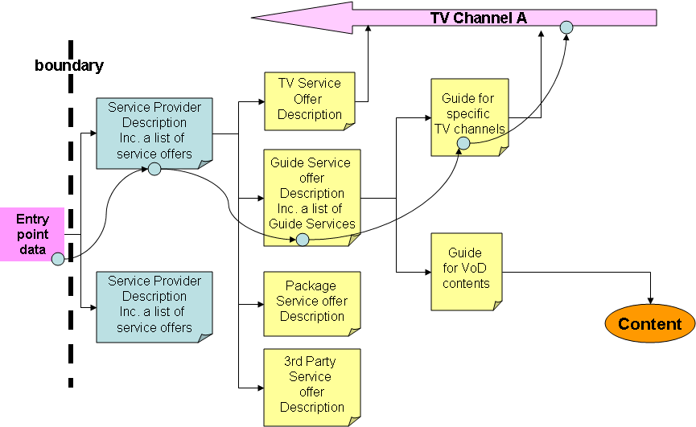
- Service/content delivery protocol
Each service has its own acquisition method as follows:

Live Media Broadcast service delivery protocol
Live Media Broadcast services are streamed continuously over IP multicast.
The element "Service Location" in the "detailed service offer" records gives all the information required to access Live Media Broadcast services.
Terminal Devices can receive or stop the reception of Live Media Broadcast services simply by issuing the appropriate IGMP messages.
Live Media broadcast services are encoded as MPEG-2 Transport Streams in compliance with TS 101 154 ("Digital Video Broadcasting (DVB); Specification for the use of Video and Audio Coding in Broadcasting Applications based on the MPEG-2 Transport Stream") encapsulated either in RTP
(Real-time Transport Protocol) according to RFC 3550 ("RTP: A Transport Protocol for Real-Time Applications") in conjunction with RFC 2250 ("RTP Payload Format for MPEG1/MPEG2 Video") or directly in UDP (User Datagram Protocol) according to ITU-T Recommendation H.610 ("Full service VDSL - System architecture and customer premises equipment").

Content on Demand service delivery protocol
- Channel Identification and location resolution
Domain names (DNS) could be used to identify destination multicast addresses of channels in EPG. These domain names would be registered on DNS servers with their corresponding multicast addresses. When end users try to access multicast channels in the EPG, their IPTV terminal devices resolve the domain names with DNS servers. When they get the multicast addresses for the domain names, they issue out group membership reports to join the multicast groups, and receive contents from the multicast channels.

Appendix : Example of service discovery
This chapter presents how the IPTV service discovery and selection is specified in TS 102 034.
The service discovery and selection (SD&S) specification in TS 102 034 covers:
- service discovery
- service selection
- the delivery of the service discovery information
The service discovery results in a list of available service, with sufficient information to make a choice/selection and to enable access to the content.
In TS 102 034 two kinds of contents are considered for live media broadcast:
- TS full SI: DVB-SI embedded in the transport stream
- TS optional SI: only PSI must be embedded in the transport stream
Nevertheless the SD&S mechanism can be easily extend to other kind of content formats.
The service discovery information are represented with and carried as XML records (XML schemas specified in a normative file).
The service discovery process is divided in three steps:
- Find service discovery entry points
The IPTV terminal looks for points in the following order:
- Entry points in the DNS domain(s) acquired via DHCP Option 15,
- Entry points in the DNS domain <services.dvb.org>,
- Well-known IANA multicast address (224.0.23.14 DvbServDisc),
- Manual entry of a URL
and stops at the step where a valid entry point has been found.
- For each service discovery entry point, collect service provider (SP) discovery information
The SP discovery information are described in the SD&S data model (XML file).
- For each service provider, collect IPTV service discovery information
The IPTV service discovery information are described:
- in the Broadband Content Guide (BCG) and in that case the IPTV service discovery information are the BCG location,
- in the SD&S data model (XML file), and them for:
Broadcast discovery records: service description and service location are provided
Content on Demand discovery records: catalogue location is provided
Service from other SP records: service description is provided
Package discovery record: service description is provided
Two transport mechanisms are described for the carriage of the SD&S information:
- HTTP: used for delivery over unicast (“pull mode”)
- DVBSTP: a light protocol specified by DVB, used for delivery over multicast (“push mode”)
Contributor note: DVBSTP was defined because no suitable standardized protocol was available from the IETF at the time of release of the specification, the future release of the specification will use a standard IETF protocol.
Figure B-1: TS 102 034 service discovery steps
_________________

